**What is an FSK Modulation?**

Frequency-shift keying (FSK) is the frequency modulation system in which digital information is transmitted through the discrete frequency change of a carrier wave. The [technology is used in communication systems](https://www.elprocus.com/phase-locked-loop-system-in-communication-systems/) such as amateur radio, caller ID, and urgent situation broadcasts. The simplest FSK is binary FSK (BFSK). BFSK uses a pair of discrete frequencies to transmit binary (0s and 1s) information. With this scheme, the “1” is called the mark frequency and the “0” is called the space frequency. The time **domain of an FSK modulated** carrier is illustrated in the figures to the right

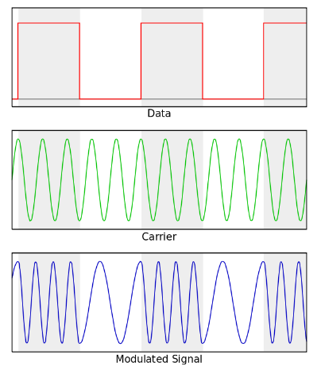Frequency Shift Keying

**FSK Modulation Circuit Using 555 Timer**

The Circuit given here illustrates how FSK modulated wave can be generated. It is build using IC555. Square pulses are given as input to represent bit 1 and bit 0, and as an output **IC555 generates FSK modulated** wave. To generate square pulses one more [IC555 is used](https://www.elprocus.com/brief-about-ic-555-timer/). The working of this circuit was very simple to understand as the output frequency of the signal was based on the digital input given to the base of the transistor.

FSK plays a vital role in a wide range of [applications in the communication field](https://www.elprocus.com/types-of-wireless-communication-applications/) and it was treated as an efficient one for wireless modems in data transmission. The above circuit is capable of producing an FSK signal with respect to the given i/p signal. The Ra, Rb and C in the circuit determine the frequency of the FSK modulated signal in the mode of Astable.

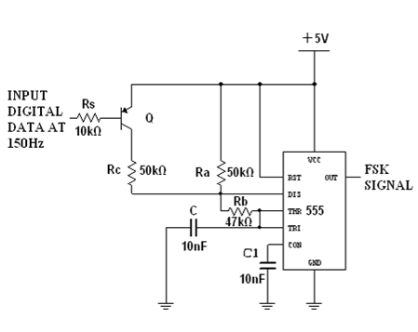FSK Modulation Circuit Using 555 Timer

The o/p frequency of the signal was based on the i/p digital signal given to the base terminal of the transistor and IC works in the Astable mode. Here the resistors Ra, Rb & Capacitor C was chosen in such a way to get o/p frequency of 1070Hz. When the i/p was high, then it is written by the following equation

**f = 1.45/(Ra + 2Rb) C**

When the i/p binary data are logic 0, the [PNP transistor](https://www.elprocus.com/difference-between-npn-and-pnp-transistor/) is ON and its connects the Rc resistance across Ra resistance. The Rc resistor is selected in such a way that the value of 1270Hz.

Here Rc value added in addition to the Ra value, Rb and Contribute to donate the working of the IC. This makes the charging & discharging faster, resulting in high-frequency waves as o/p. The **resistors and capacitor values** were selected in such a way to get an o/p frequency of 1270 Hz. This was given by the following equation.

**F = 1.45/(( Ra || Rc ) + 2Rb ) C**

Therefore, the output of an FSK will give 1070Hz frequency when i/p is high & 1270 frequencies when an input is low. So by this technique, the FSK signal was gained using NE555.

**FSK Demodulation**

FSK demodulator is a very beneficial application of the 565 PLL. In this, the frequency shift is generally proficient by [motivating a VCO](https://www.elprocus.com/voltage-controlled-oscillator-working-application/) with the binary data signal. So that the two subsequent frequencies resemble the logic 0 & 1 states of the binary data signal. These frequencies corresponding to two states are generally called the mark and space frequencies. Numerous values are used to set the mark & space frequencies. An FSK signal demodulator can be made as shown in the figure. The demodulator gets a signal at one of the two separate carrier frequencies, representing [the RS-232](https://www.elprocus.com/max232/)C logic levels of mark or space, respectively. The capacitive connection is used as the i/p to eliminate a DC level.

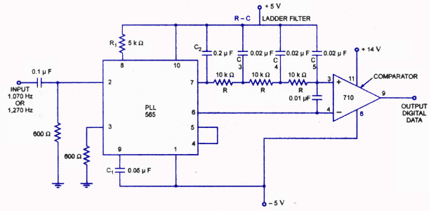FSK Demodulation Circuit

As the signal seems at the i/p of 565 PLL, this lock to the i/p frequency and the paths it between the two probable frequencies with an equivalent DC shift at the o/p. Resistor and capacitor control the free-running frequency of the VCO. Here, C2 capacitor is a loop filter capacitor that founds the energetic characteristics of the demodulator. This capacitor is selected slighter than the normal one to remove overshoot on the o/p pulse.

A 3-stage **RC ladder filter** is used to remove the sum frequency component from the o/p. The VCO frequency is familiar with a resistor. So that the level of DC voltage at the o/p pin-7 is the same as that at pin-6. An i/p at 1,070 Hz frequency makes the demodulator o/p voltage to a more positive voltage level, driving the digital o/p to the high level. An input at 1270 Hz similarly drives the 565 DC o/p less positive with the digital o/p, which than falling to lower levels.

Thus, this is all about FSK modulation and demodulation. We hope that you have got a better understanding of this concept. Furthermore, any queries regarding this topic or [types of modulation techniques](https://www.elprocus.com/different-types-of-modulation-techniques-in-communication-systems/) or any [DIY project kits](https://www.elprocus.com/free-diy-electronics-project-for-engineering-students/).  Please give your valuable suggestions by commenting in the comment section below, Here is a question for you, **What is phase shift keying?**